|  |
| --- |
| Serial No: |
| **Sessional I** |
| **Total Time: 60 minutes** |
| **Total Marks: 50** |
| ________________  Signature of Invigilator |

|  |
| --- |
| **CS301-Theory of Automata** |
| Saturday, Sept 24, 2016 |
| **Course Instructor** |
| Dr. Aftab Maroof, Dr Waseem Shehzad, Dr Labiba Fahad, Ms. Mehreen Alam |

|  |
| --- |
| **_____________________________________________ _____________________**  Student Name Roll No Section Signature |

## DO NOT OPEN THE QUESTION BOOK OR START UNTIL INSTRUCTED.

**Instructions:**

1. In all questions, use the algorithms studied in the class and show all steps to get full credit.
2. Understanding the question paper is also part of the exam, so do **not** ask any clarification.
3. The question paper is printed on both sides of the pages.
4. Attempt all questions on the same sheets/pages and within the space provided with each question. You may lose marks if you write in extra space.
5. Make sure that this question paper contains eight **(08)** pages including title page. Be brief, smart and efficient!
6. Use permanent ink pens only. Any part done using soft pencil will not be marked and cannot be claimed for rechecking.

|  |  |  |  |  |  |  |  |
| --- | --- | --- | --- | --- | --- | --- | --- |
| Question | 1 | 2 | 3 | 4 | 5 | 6 | **Total** |
| **Marks Obtained** |  |  |  |  |  |  |  |
| **Total**  **Marks** | 5 | 10 | 10 | 5 | 10 | 10 | **50** |

**Vetted By: _____________________________Vetter Signature: _____________________**

Q1. [5 pts] Give recursive definition of language defined over alphabet Σ = {a, b}, having all strings **not** ending with aa or bb.

Q2. [5+5 =10 pts]Write regular expression for each of the following language defined over alphabet Σ ={a, b}

1. Language of strings **not** having bb or aa at any place
2. Language of all strings having number of b’s in multiples of 2

Q3. [10 pts] Convert the following GTG to a regular expression. Show all the steps.

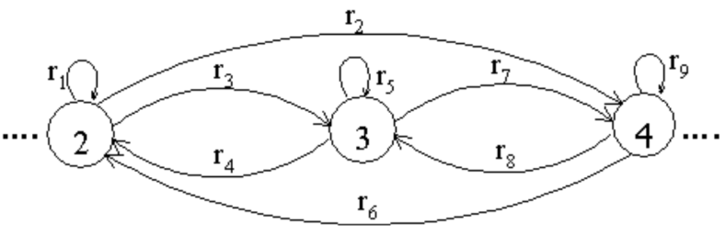

Q4. [5 pts] Convert the regular expression ( (ab)*b )* to NFA.

Q5. [10 pts] Convert the following NFA to the corresponding DFA. Show the resultant transition table and the state diagram.

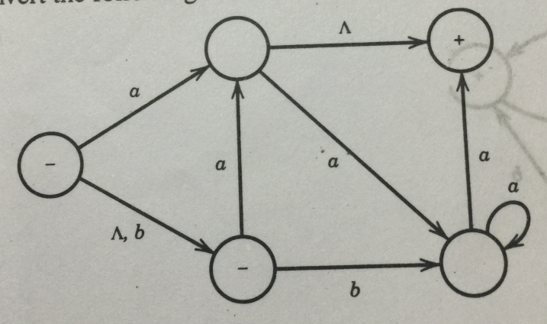

Q6. [ 10pts ] Minimize the following (copy diagram from the book) DFA. Show the resultant state diagram and transition table.

